**IRevolution A Data _Drive Exploration of Apple’s IPhone Impact in India**

**1.Introduction**

* 1. **Overview:**

The objective of this study is to obtain a thorough understanding of how Apple's iPhone would affect the Indian market. In particular, we want to investigate the market penetration of iPhones in India, comprehend consumer preferences and decision-making processes, and assess the social and economic effects of iPhone adoption. We aim to offer insights that can direct strategic decisions for Apple and other stakeholders active in the Indian smartphone industry by leveraging data analytics and visualizations using Tableau.

* 1. **Purpose:**

The project's business needs call for data analysis and visualization in order to understand how Apple's iPhone has affected India. This entails looking at customer choices, market penetration, sociological developments, and economic effects. Tableau visualizations should be interactive, understandable, and educational so that stakeholders can make data-driven decisions and comprehend the impact of the iPhone on the Indian market.

1. **Problem statement & Design thinking:**

An important component of this study is the societal impact of Apple's iPhone in India. We intend to investigate how the iPhone has altered communication, information access, and social relationships in Indian society through data analytics and Tableau visualizations. Studying the impact of iPhones on social media use, online content consumption, and the broader digital divide are all included in this. Policymakers and organizations can better manage the benefits and difficulties brought on by the expanding smartphone adoption by understanding the social impact.

Research must focus on how Apple's iPhone has affected business in India. We seek to examine the economic effects of iPhone uptake in the Indian market using data analytics and Tableau visualizations. Examining iPhone sales data, market share, revenue creation, and its effects on different industries like e-commerce, app development, and digital payments are all part of this. Organizations can find possibilities for growth and innovation by understanding the business impact and using it to help them position themselves in their markets and make strategic decisions.

* 1. **Empathy map**

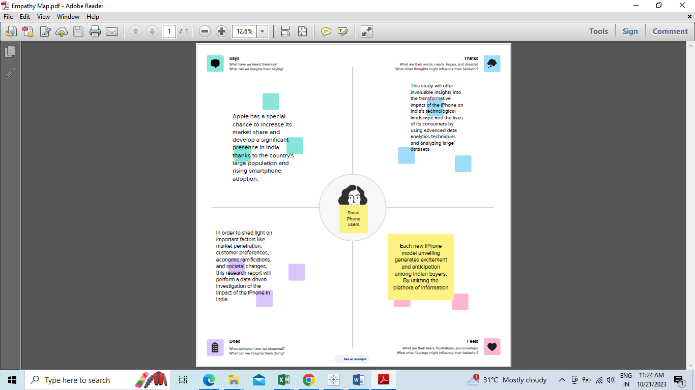

* 1. **Ideation and Brain Strom**

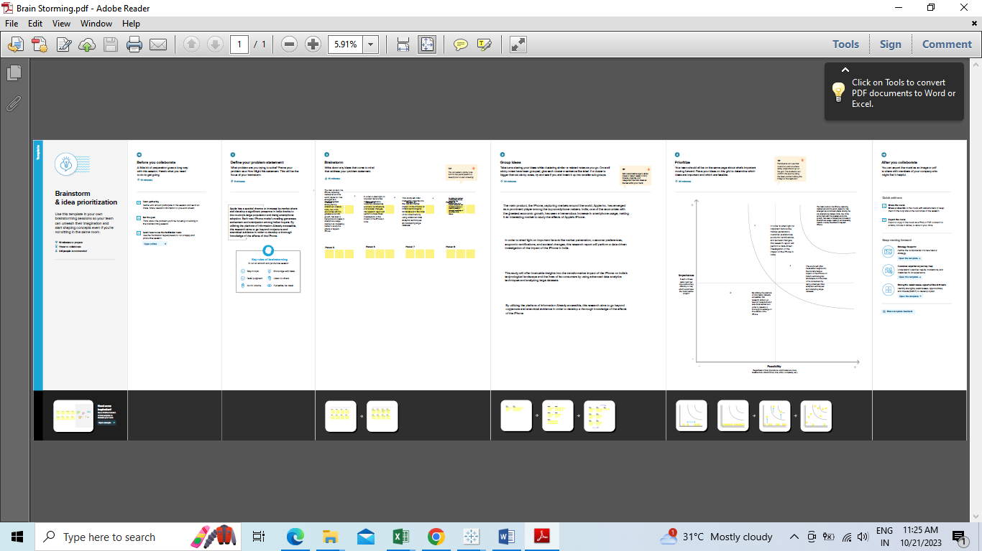

1. **Result**

